System Proposal
By
Yuva Teja Jagarlamudi

Table of Contents
1. Introduction 3
2. System Request 3
3. Requirements Definition 6
4. Analysis models 9
4.1 Use-case diagram 9
4.2 Activity diagram 11
4.3 Sequence diagram 12
4.4 Class diagram with messages matching your sequence diagram 13
4.5 Object diagram 15
5. Traceability Table: Use Cases and Supporting Classes 16
6. Preliminary Design and Implementation Thoughts 16
7. References 18

1. Introduction
Jagarlamudi Civic Tech is a fictional start-up created for this academic project with the goal of improving city maintenance through digital innovation. The company focuses on helping residents quickly report street-related problems such as potholes, broken lights, and damaged sidewalks. Traditional reporting methods like phone calls and emails are often slow and inefficient, causing unnecessary delays in issue resolution. To solve this, Jagarlamudi Civic Tech is developing a user-friendly web platform that allows residents to log in, upload images, and submit problem reports with location details. Municipal staff can then view these tickets, prioritize them based on severity, and update their progress through a dashboard. The system also includes intelligent features such as rule-based prioritization, overdue flagging, and workload balancing to simulate real municipal operations. Weekly performance reports enhance transparency and accountability. Overall, the project highlights how simple digital tools can improve urban safety, communication, and service responsiveness.

2. System Request
System Request: Street Issue Reporter
Project Sponsor: Yuvateja Jagaralamudi
Business Need:
Urban residents often face unsafe or damaged streets, including potholes, broken streetlights, and unsafe sidewalks. Current reporting methods, such as phone calls or emails to local authorities, are slow and inefficient, causing delays in repairs and public frustration. This project will create a web-based Street Issue Reporter that allows residents to submit street problems with images, location, and descriptions. Municipal staff can view, prioritize, and update tickets on a dashboard. The system improves transparency, speeds up issue reporting, and simulates municipal workflows for educational demonstration. The system will run fully on a local laptop. Residents will create sample tickets, upload images, and select locations. Staff roles will log in to view tickets, update statuses, and demonstrate prioritization, flagging, and reporting features. All functionality will be visible during the class demo without requiring actual city personnel.
Business Requirements:
- Users (residents and municipal staff) can create accounts and log in.
- Residents can submit street issues with images, location, and short descriptions.
- Each ticket is automatically assigned a priority score based on severity and time since submission.
- Tickets are displayed on the dashboard sorted by priority, showing the most urgent issues first.
- Tickets unresolved for more than three days are automatically flagged as overdue for staff attention.
- Tickets can be automatically assigned to staff users based on their current workload.
- Municipal staff can update ticket status: Submitted or In Progress or Resolved.
- The system generates weekly summary reports, including total tickets, resolved tickets, overdue tickets, average resolution time, and severity trends.
- Tickets in the same area can be grouped for batch processing.
- Tickets flagged as overdue for more than five days are escalated to admin for immediate attention.
- Residents receive notifications when their issue status changes (simulated for the demo).
- The system must comply with data privacy rules, protecting personal information and uploaded images.
- The web app must remain lightweight and run locally without paid APIs.
- The interface should be simple and user-friendly for residents with limited technical knowledge.
Unique Business Logic:
I am adding unique business logic to my system that implements rule-based ticket prioritization to simulate real municipal decision-making. Tickets with higher severity are automatically moved to the top of staff dashboards. Unresolved tickets are flagged and escalated to ensure timely follow-up. Tickets are assigned based on staff workload, simulating realistic municipal staff management. Weekly summary reports provide insights into ticket resolution trends and areas of concern. This logic ensures the system demonstrates meaningful workflow and decision-making rather than simple data storage.
Business Value:
- Improves response time for street issues and reduces hazards by 10–30% (Mistele, 2025).
- Demonstrates transparency and accountability between residents and municipal staff.
- Shows workflow management and decision-making, providing a realistic municipal operations model (Mistele, 2025).
- Reduces manual effort for issue reporting, saving residents and staff time.
- Provides a scalable framework for future municipal applications.
Special Issues or Constraints:
- Must remain easy to use for residents unfamiliar with web applications.
- Runs entirely locally without paid APIs; no external servers required.
- All personal data and images must comply with local privacy regulations.
- Matching, flagging, and prioritization logic must remain efficient with growing tickets.

3. Requirements Definition
User Requirements
Residents
- Resident creates account with name, email, and password.
- Resident logs in securely.
- Resident resets password if forgotten.
- Resident updates personal profile details.
- Resident submits new street issue with image, location, and description.
- Resident edits issue before staff review.
- Resident cancels submitted issue.
- Resident views list of submitted issues.
- Resident views status of each issue (Submitted, In Progress, Resolved).
- Resident receives confirmation after submitting an issue.
- Resident receives notification when issue status changes.
- Resident receives notification if issue flagged as overdue.
- Resident views issue location on map.
- Resident filters issues by status or date.
- Resident downloads personal issue history.
Municipal Staff
- Staff logs in.
- Staff views all submitted tickets in dashboard.
- Staff views ticket details including image, description, and location.
- Staff edits ticket details if unclear.
- Staff updates ticket status (Submitted, In Progress, Resolved).
- Staff reassigns ticket to another staff user.
- Staff marks ticket as priority based on severity.
- Staff receives notification when new ticket assigned.
- Staff views workload summary (tickets assigned).
- Staff filters dashboard by priority level.
- Staff groups tickets from same area for batch action.
- Staff flags ticket as duplicate and merges with existing.
- Staff views overdue tickets list.
- Staff escalates overdue ticket to admin.
- Staff generates daily summary of assigned tickets.
Admins
- Admin creates and approves staff accounts.
- Admin deactivates staff accounts when needed.
- Admin views all tickets and their statuses.
- Admin reviews escalated overdue tickets.
- Admin reassigns overdue tickets to available staff.
- Admin configures priority rules for ticket scoring.
- Admin configures rules for overdue flagging.
- Admin generates weekly summary reports (resolved, overdue, average time).
- Admin views severity trends by category.
- Admin monitors system usage logs.
Non-functional Requirements
1. Performance
System must display dashboard results within 3 seconds for up to 500 active tickets.
2. Availability
System must be available during demo hours with 99% uptime on local laptop setup.
3. Scalability
System must support at least 1,000 tickets without slowdown during class demonstration.
4. Security
All passwords stored using hashing; images and personal data stored securely.
5. Privacy
Uploaded resident details and photos must not be shared outside system.
6. Constraint
System must run locally without paid APIs or external hosting.
7. Usability
Resident must be able to submit an issue within 2 minutes from login in usability tests.
8. Accessibility
Interface must support large fonts and clear layout for residents with limited skills.
9. Maintainability
Code must be modular; bug fixes applied within 48 hours during testing.
10. Backup & Recovery
Data backed up daily; recovery time objective (RTO) ≤ 4 hours.

4. Analysis models

4.1 Use-case diagram
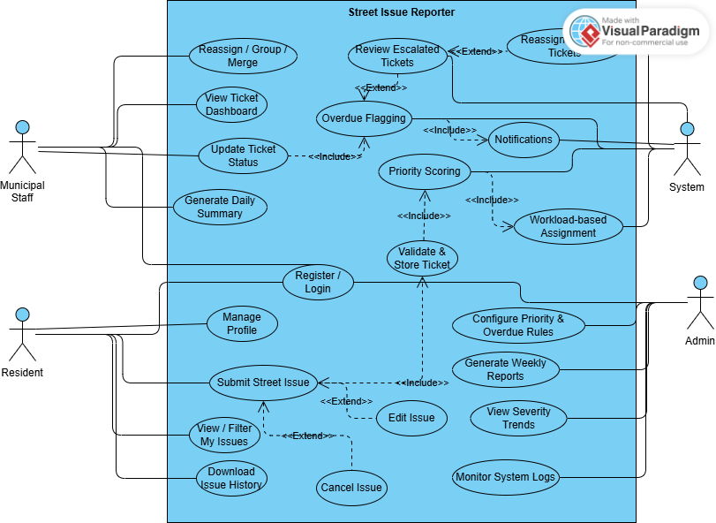

Figure.1 Use Case Diagram
Figure.1 Use Case Diagram provides a clear overview of how different users interact with the Street Issue Reporter system. It identifies the three main actors; Residents, Municipal Staff, and Admin and outlines their primary functions within the system. Residents can create accounts, log in, and submit issues with descriptions and images. Municipal staff view these tickets, update their status, group or merge similar issues, and ensure timely resolution. The Admin manages configuration, assigns staff, and reviews escalations or overdue reports. Each oval in the diagram represents a specific function connected to an actor, showing the flow of interactions between users and the system. This diagram helps visualize the system boundaries, ensures that all required user functions are covered, and assists in identifying redundant or missing operations early in the design stage. It provides a foundation for understanding how each role contributes to the system’s workflow and operations.

4.2 Activity diagram
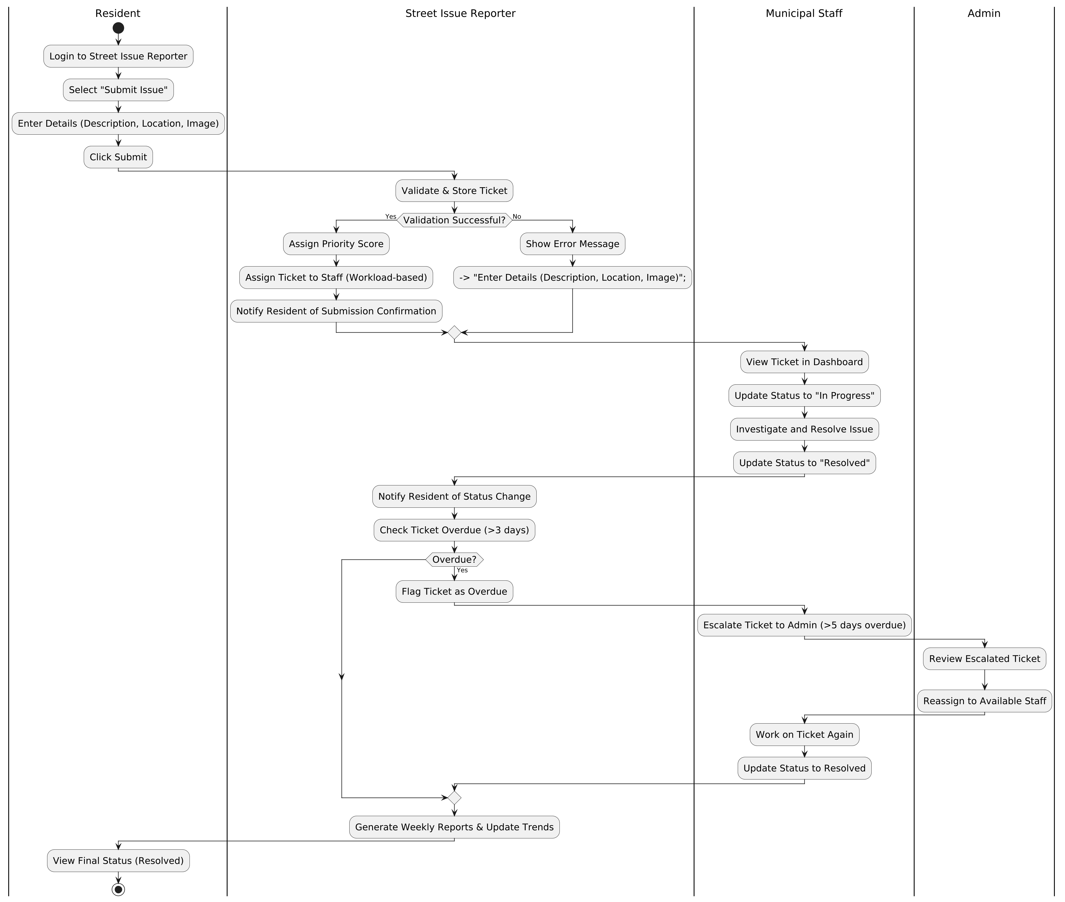
Figure.2 Activity Diagram
The Figure.2 Activity diagram illustrates the logical sequence of actions when a resident submits a street issue in the Street Issue Reporter system. The process starts when the resident logs in, fills out the issue form with a description, location, and image, and submits the data. The system then validates the inputs, assigns a severity score, and automatically routes the ticket to an available staff member. Decision nodes manage alternate paths such as incorrect data or missing fields, ensuring robust handling of real-world scenarios. The activity continues as staff review and update the ticket’s progress until resolution. This diagram highlights both user and system responsibilities, emphasizing how data flows and transitions occur at each step. By visualizing these actions, developers and stakeholders can clearly understand how the system responds under various conditions. It ensures that each action is traceable and that the workflow is consistent, efficient, and easy to implement.

4.3 Sequence diagram
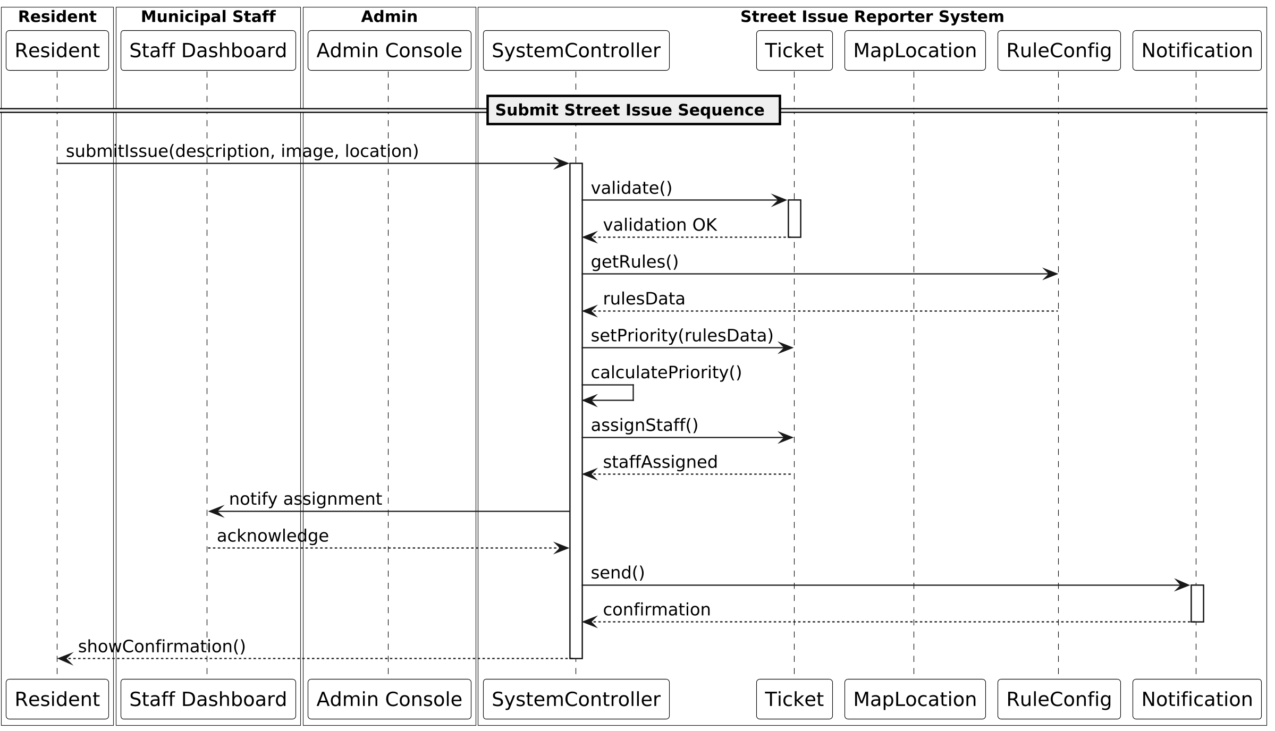
Figure.3 Sequence Diagram
The Figure.3 Sequence Diagram illustrates how objects interact in a time-ordered sequence when a street issue is reported and processed. It shows the communication flow among key components such as the Resident, Interface, SystemController, Ticket, and Notification modules. The process begins when a resident submits an issue, followed by system validation, ticket creation, priority scoring, and staff assignment. Notifications are then sent to both resident and staff. Each message arrow indicates a request or response between objects, representing how control passes throughout the system. This diagram visually demonstrates the step-by-step logic behind the Submit Street Issue use case and ensures that all processes occur in the correct order. It is especially helpful for identifying potential timing issues or bottlenecks between system components. By capturing the exact message flow, the sequence diagram guides developers in implementing consistent data handling, synchronization, and event-driven behavior across the application.

4.4 Class diagram with messages matching your sequence diagram

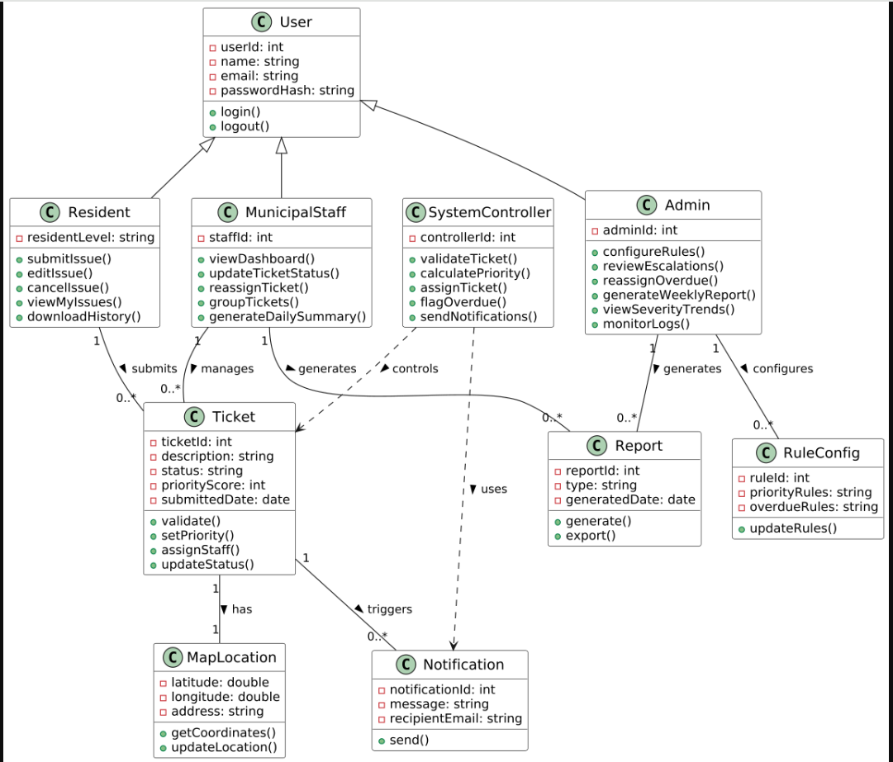
Figure.4 Class Diagram
The Figure.4 Class Diagram represents the static structure of the Street Issue Reporter system. It identifies key classes such as User, Resident, MunicipalStaff, Admin, Ticket, Notification, Report, MapLocation, RuleConfig, and SystemController. Each class contains attributes and methods that describe its role in the system. Relationships, including inheritance and associations, show how data flows between components. For instance, Resident, Staff, and Admin inherit from the User class, while Ticket connects to both Resident and Staff. RuleConfig defines ticket prioritization and overdue thresholds, while Notification and Report handle communication and analytics. This diagram establishes how the system’s objects interact logically and structurally. It supports database design, code implementation, and modular organization. By defining clear connections between entities, the class diagram ensures that every system feature has a corresponding structural component, making development consistent, scalable, and easy to maintain during both testing and implementation phases.

4.5 Object diagram
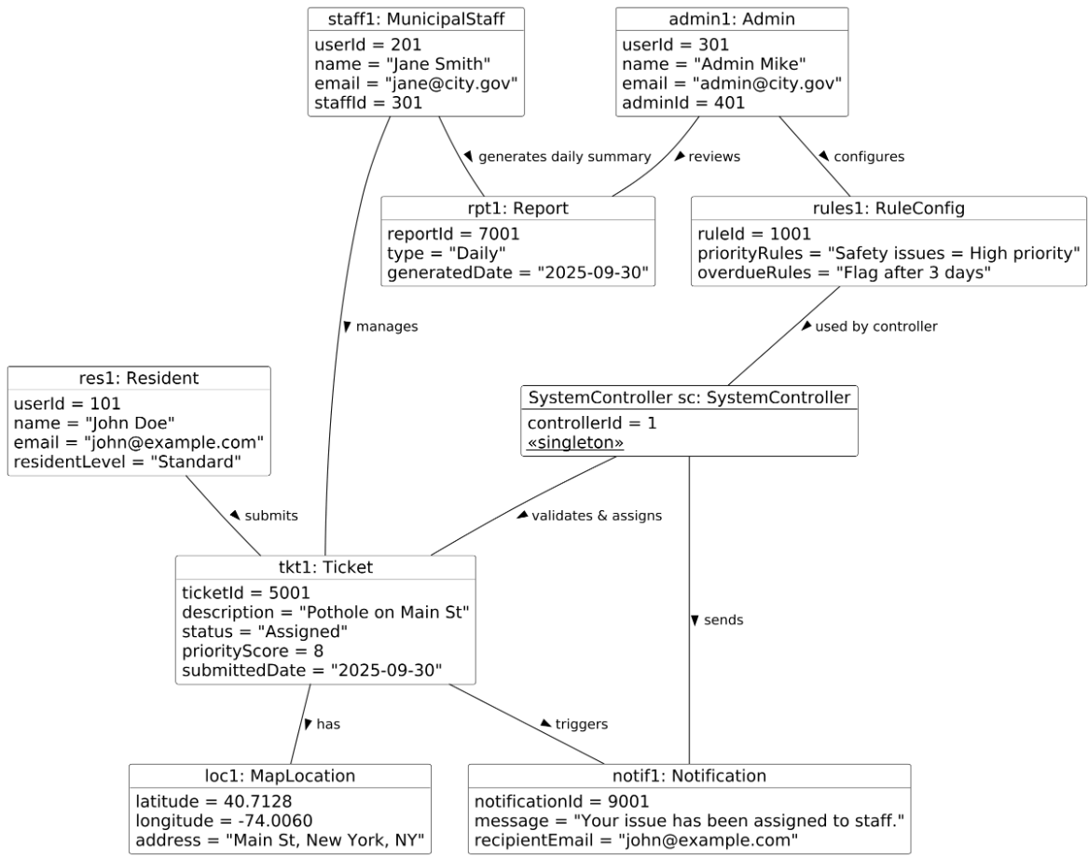
Figure.5 Object Diagram
The Figure.5 Object Diagram provides a snapshot of the system’s state at a specific moment during execution. It illustrates real instances of classes such as Resident, Ticket, Staff, and Admin interacting with each other. For example, a Resident object may have created a “Pothole Issue” Ticket, which is assigned to a specific Staff object for resolution. The diagram demonstrates how actual data populates class relationships, converting abstract definitions into real-world entities. It helps validate the logical relationships and ensures the correctness of associations designed in the class diagram. This view is particularly useful during testing, as it shows how multiple objects coexist and exchange data dynamically. It also confirms that system relationships like one-to-many or many-to-one behave correctly in practice. Ultimately, the Object Diagram bridges design and implementation by showing how system components interact in live scenarios within the Street Issue Reporter environment.

5. Traceability Table: Use Cases and Supporting Classes
Use Case | Use Case Name | Supporting Classes
1 | Register / Login | User, SystemController
2 | Manage Profile | Resident, User
3 | Submit Street Issue | Resident, Ticket, MapLocation, SystemController
4 | Edit Issue | Resident, Ticket, SystemController
5 | Cancel Issue | Resident, Ticket, SystemController
6 | View / Filter My Issues | Resident, Ticket
7 | Download Issue History | Resident, Ticket, Report
8 | View Ticket Dashboard | MunicipalStaff, Ticket, SystemController
9 | Update Ticket Status | MunicipalStaff, Ticket, SystemController
10 | Reassign / Group / Merge | MunicipalStaff, Ticket
11 | Generate Daily Summary | MunicipalStaff, Report
12 | Configure Priority & Overdue Rules | Admin, RuleConfig, SystemController
13 | Review Escalated Tickets | Admin, Ticket, RuleConfig
14 | Reassign Overdue Tickets | Admin, Ticket, MunicipalStaff, SystemController
15 | Generate Weekly Reports | Admin, Report
16 | View Severity Trends | Admin, Ticket, Report
17 | Monitor System Logs | Admin, SystemController
18 | Validate & Store Ticket | Ticket, SystemController
19 | Priority Scoring | Ticket, RuleConfig, SystemController
20 | Workload-based Assignment | Ticket, MunicipalStaff, SystemController
21 | Overdue Flagging | Ticket, RuleConfig, SystemController
22 | Notifications | Notification, SystemController

6. Preliminary Design and Implementation Thoughts
The preliminary design for the Street Issue Reporter system focuses on simplicity, modularity, and scalability for local demonstration. The user interface will be developed using HTML and CSS to create a clean and easy-to-navigate layout for residents, municipal staff, and administrators. The backend will be powered entirely by the Flask framework in Python, which is chosen for its lightweight structure, simplicity, and strong support for rapid web application development. A MySQL database will be used to manage ticket, user, and notification data securely and efficiently. The system will follow the Model-View-Controller (MVC) design pattern to separate business logic, interface elements, and database operations. The implementation will be completed incrementally, beginning with user registration and login, followed by issue submission, dashboard functionality for staff, and rule-based ticket prioritization. Reporting features and system testing will be conducted in later phases to validate performance, usability, and accuracy in a local environment.

7. References
Mistele, B. (2025, June 2). How AI can help protect vulnerable road users. Forbes Technology Council. https://www.forbes.com/councils/forbestechcouncil/2025/06/02/how-ai-can-help-protect-vulnerable-road-users/

